

CONTENT PLANNING WORKSHEET

Now it's time to decide what kind of content you want in each section of your portfolio!

**SECTION 1: ABOUT**

1. Let's start with a compelling intro (1 sentence or so). Start by sharing your name, who you are, and just enough about you to get us intrigued.

*I’m Eric Lahoda, a Web Developer with Code, Visual Design and Marketing skills.*

1. Tell us something about yourself that's fun, unique, or relatable (1 sentence should do ya). It doesn't have to be work-related!

*As an engineer, I have an eye for problem solving and as a sales person an ear for listening. I really enjoy the using the intuitive other half of the mind.*

1. Now tell us about your fantastic skills (3-6 is about right)! Be sure to highlight your strengths and interests, and call out the areas you want more experience in.

* *Web development* 
  + *proficient in HTML and CSS*
  + *Responsive development*
  + *Code from existing “Visual Comp”*
* *Visual design with focus on both Ux and Ui*
  + *Discovery of site goals, concept sketch to finished “Visual Comp”*
  + *Consistent branding from Website, to Business card*
  + *Proficiency in Industry standard tools, Photoshop, Illustrator, InDesign*

1. Do you have a great (professional) photo of yourself? Be sure to include it!



**SECTION 2: WORK**

1. Tell us about your work samples (3 is a good start)! Include a representative image of the project (a high resolution screenshot will do), the name of the project (make it a link if possible), and your role in the project. If you have a client, list them as well. If you're having trouble with this step, might we suggest your icon, business card, and portfolio design comp?

Project Image: 

Project Name: LE Rentals Icon

Client: Lahoda REvest, LLc

Role: Designer

Project Image: 

Project Name: Business Card

Client: Lahoda REvest, LLC

Role: Designer

Project Image: 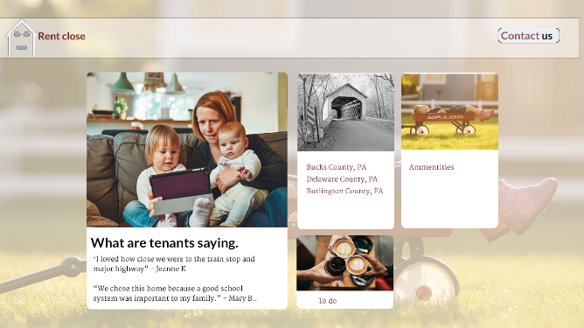

Project Name: Rental Website

Client: Lahoda REvest, LLC

Role: Designer

**SECTION 3: CONTACT**

What's the best way for fans and clients to reach you? Do you share on social media? Make sure to include a link to your website in all your social profiles!

* Direct contact
  + Phone:215-939-5149
  + Email: Hi@BestTechService.com
* Social media
  + LinkedIn: https://www.linkedin.com/in/ericlahoda/
  + Dribble: https://dribbble.com/ericlahoda
  + Behance: https://www.behance.net/elahoda9b06
  + Twitter: https://www.instagram.com/ericlahoda/
  + Instagram: https://www.instagram.com/ericlahoda/
  + Facebook: https://www.facebook.com/eric.lahoda